GVSU CIS 162 Project 2 Dice Game

Singharaj Usai

10/19/2023

I pledge that this work is entirely mine, and mine alone (except for any code provided by my instructor). "

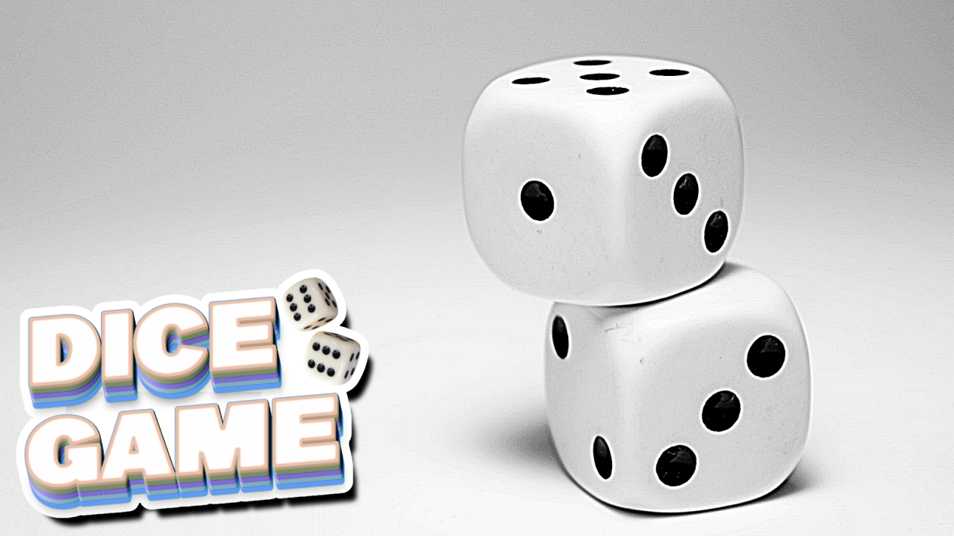

Developer Journal:

**Friday October 13, 2023 (Total time - 15 min) :**

* Started working on the dice game project. Watched the lecture video Professor Scott uploaded and Project 2 hint to get started on the project.
* Import project to Github. Start on the roll_dice function from the lecture video hint.

**October 15, 2023 (Total time - 1 hour):**

* Work on Step 2: computer_turn function and if statements. Work on bug fixing the function to pass unit tests, struggled.

**October 18, 2023 (Total time - 4 hours):**

* 11:31 AM - Continue trying to fix computer_turn function to pass unit tests for Zybooks, passed all but 1 computer_turn test.
* 11:40 AM - Started working on human_turn function. Use while loop as the instruction says, and call the roll_dice() function to roll random dice
* 11:54 AM - work on choice input prompt to continue rolling the dice or not, and pritns the total turns and the game score.
* 12:15 PM - start working on the human_vs_computer function. Instruction says to use a while loop for the scores to compare the score to continue until you or the computer gets at least 100 points.
* 12:29 PM - If you get more than 100 points, print “You Won!” to the console, and end the game. If the computer wins, print the computer won and also end the game.
* 12:36 PM - go back to computer_turn function and add prints to each if statements to maybe debug or see if anything prints.
* 9:06 PM - modify the if __name__ = “__main__”: prints to see what’s printing.
* 10:15 PM - Work on computer_solo function, make it so it uses a while loop so the computer keeps making turns alone until it rolls to 100 points
* 11:24 PM - Started on world_champion func, very confusing on why unit tests wouldn’t pass because the dice rolls wouldn’t meet what Zybook wanted, and there was a lot of print logs.

**October 19, 2023 (Total time - 30 Minutes):**

* 7:04 PM - Continue fixing world_champion func to get it to pass Zybook tests, remade comparison if statements . It passed all but 1 test. Add comments to codes explaining what each line does

**October 20, 2023 (Total time - 30 minutes):**

* 11:35 AM - Due date is today. Trying to fix the remaining 2 unpassed unit tests before 5 PM. Might not be able to finish the validation function on time since I been trying to fix the unit tests. Hardest project :(

**GitHub Project Link: [https://www.github.com/singharaj-usai/GVSU-CIS162-Project-2](https://github.com/singharaj-usai/GVSU-CIS162-Project-2)**

* All of my commit history and activities and proof of work can be found on the GitHub link

**IDE Used:** [Jetbrains IntelliJ IDEA](https://www.jetbrains.com/idea/)